الاتـحــادية الجـزائـريـة لألـعـــــاب القــــــوى
Fédération Algérienned'Athlétisme

RESULTATS TECHNIQUES

6^{ES}CHAMPIONNATS ARABESU18
TUNIS – TUNISIE 02 – 04 NOVEMBRE 2017

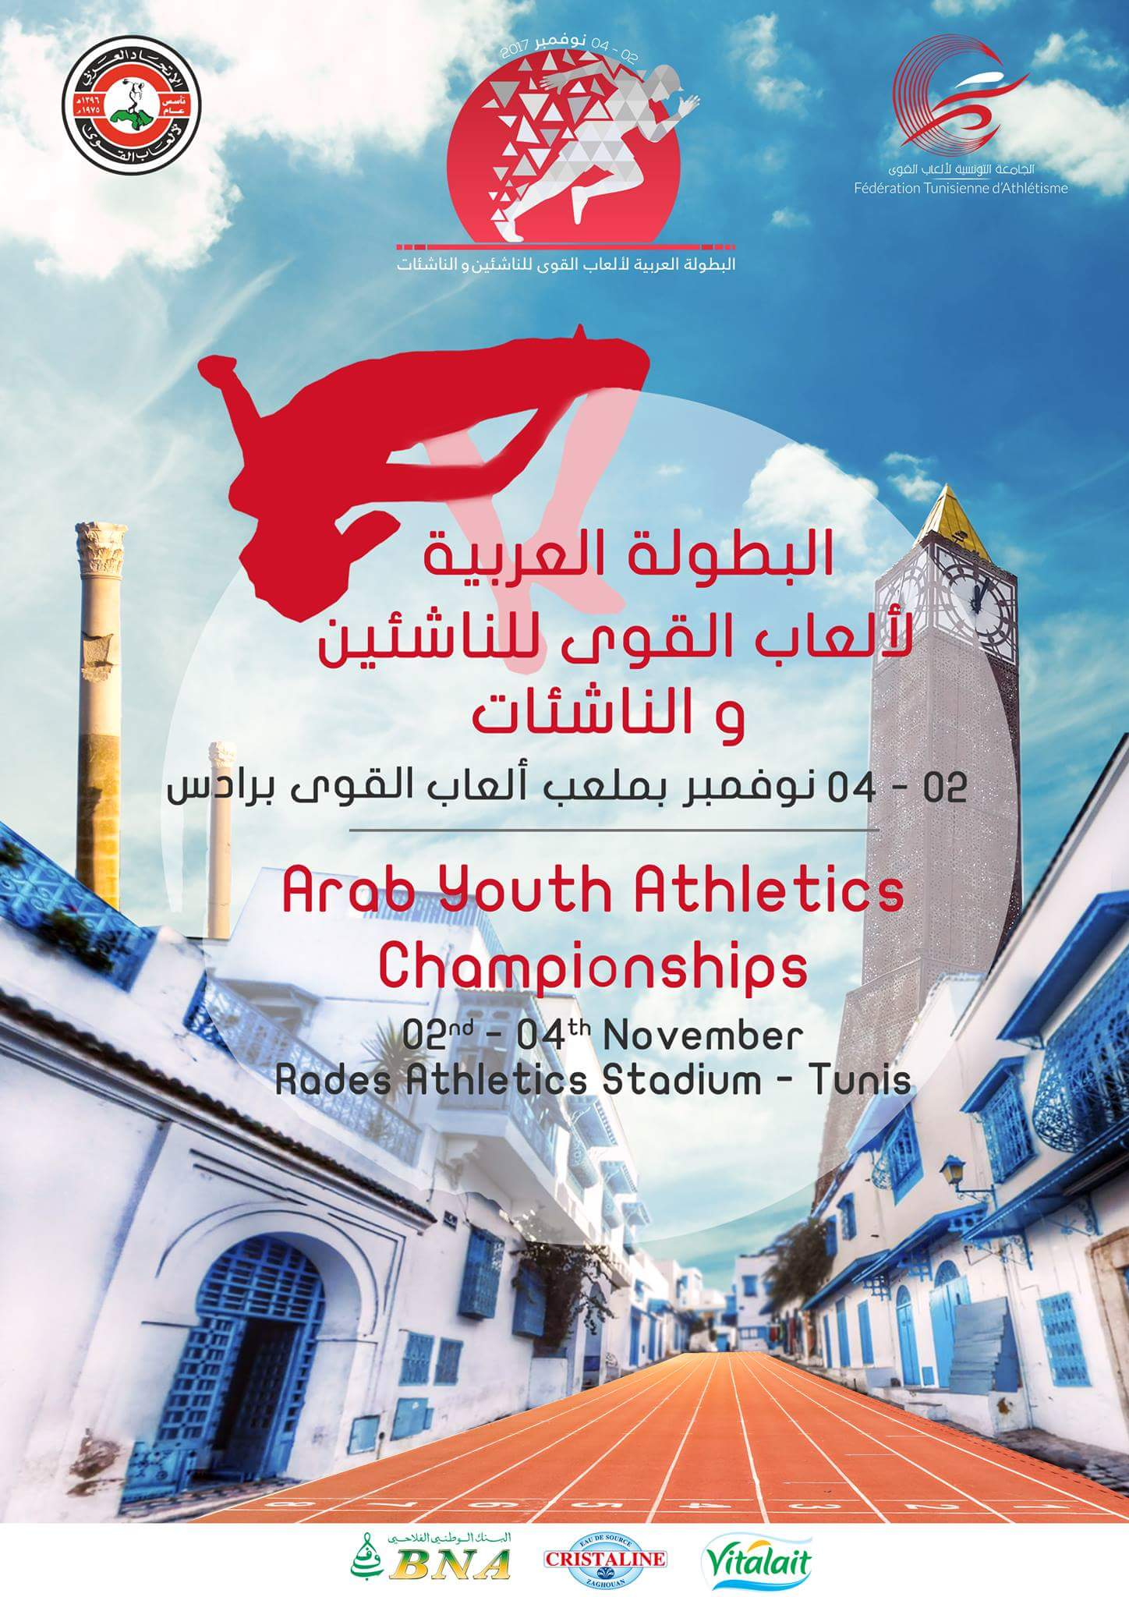

Tarik KESSAI
DJTS-FAA

RECAPITULATIF DES RESULTATS TECHNIQUES

N° | NOM | PRENOMS | A.N | SEX | CLUB | CW | EPREUVES | MINIMA | R.N | P.B | RESULTAT | 1er | CLS
 | SMAIL | NASSIMA | 2001 | F | RBS | 06 | 2000m Steeple | 7.01.13/8.07.32 | 6.54.28 | 7.46.65 | 7.29.41 | 6.55.82 | BRONZE
 | AZZI | SOUHILA | 2000 | F | MBB | 06 | 5000m Marche | 27.09.06/27.47.97 | 24.45.0 | 25.01.7 | 26.00.31 | 24.19.55 | BRONZE
 | HAMMOUMRAOUI | KATIA | 2000 | F | ACSA | 06 | Disque | 40.57 | 39.79 | 39.79 | 35.30 | 36.60m | BRONZE
 | HAMMOUMRAOUI | KATIA | 2000 | F | ACSA | 06 | Poids | 13.40 | 14.18 | 12.23 | 12.20 | 13.81m | BRONZE
 | TAOURIRT | AMINE | 2000 | M | ACB | 06 | Décathlon | 5547 | 6170 | 5658 | 5437 | 5686 Pts | BRONZE
11.92 (-1.8) – 5.99 (-0.2) – 13.00 – 1.55 – 54.43 – 16.09 (+0.1) – 28.81 – 3.30 – 35.09 – 5.09.07

 | ABIDI | MEHDI | 2000 | M | CSSET | 06 | 10.000m Marche | 47.23.17/48.10.90 | 44.58.04 | 46.13.02 | 48.40.39 | 47.40.39 | 4e /F
 | KHELOUFI | CHAHRAZED | 2000 | F | CSHB | 06 | Marteau | 54.54/R.N | 52.27 | 52.27 | 46.99 | 48.66m | 4e /F
 | KHOUFACHE | SAID | 2001 | M | RCA | 06 | 10.000m Marche | 47.23.17/48.10.90 | 44.58.04 | 47.15.0 | 48.42.16 | 47.40.39 | 5e /F

