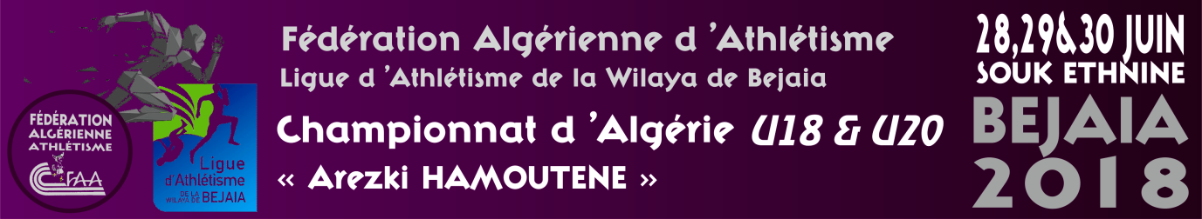

Place | clubs | Wilaya | Or | Argent | Bronze | Total
1 | CRC | 16 | 7 | 6 | 2 | 15
2 | GSP | 16 | 7 | 2 | 3 | 12
3 | OFAC | 16 | 6 |  | 6 | 6
4 | OAB | 16 | 6 | 1 | 1 | 8
5 | MBB | 06 | 4 | 2 | 3 | 9
6 | IRBOS | 31 | 3 |  | 3 | 3
7 | AMB | 06 | 2 | 4 | 2 | 8
8 | NRD | 16 | 2 | 2 | 4 | 8
9 | IRCW | 31 | 2 | 2 | 1 | 5
10 | RCArba | 09 | 2 | 1 | 1 | 4
11 | CROM | 02 | 2 | 1 |  | 3
11 | CSSMT | 02 | 2 | 1 |  | 3
13 | ACB | 06 | 2 |  | 2 | 4
14 | ACSA | 06 | 2 |  | 1 | 3
15 | IRBK | 39 | 2 |  | 2 | 2
16 | NCBBA | 34 | 2 |  | 2 | 2
17 | MAC | 25 | 1 | 3 | 2 | 6
18 | AMCB | 06 | 1 | 3 | 2 | 6
19 | CSJAA | 15 | 1 | 3 |  | 4
19 | JSMBA | 16 | 1 | 2 | 3 | 6
21 | ASSN | 16 | 1 | 2 |  | 3
21 | OBBA | 34 | 1 | 2 |  | 3
23 | HOM | 13 | 1 | 1 | 3 | 5
24 | USB | 07 | 1 | 1 | 2 | 4
25 | SSM | 16 | 1 | 1 | 1 | 3
26 | OCR | 16 | 1 | 1 |  | 2
26 | ACW | 16 | 1 | 1 |  | 2
26 | CSHB | 06 | 1 | 1 |  | 2
26 | ACK | 36 | 1 | 1 |  | 2
26 | ACSS | 19 | 1 | 1 |  | 2
26 | CSTH | 39 | 1 | 1 |  | 2
26 | JSC | 06 | 1 | 1 |  | 2
33 | CAOT | 38 | 1 |  | 1 | 2
33 | JSA | 15 | 1 |  | 1 | 2
33 | ROC | 16 | 1 |  | 1 | 2
36 | CNN | 16 | 1 |  | 1
36 | ABTAL | 22 | 1 |  | 1 | 1
36 | ACDBK | 15 | 1 |  | 1 | 1
36 | ASPA | 02 | 1 |  | 1 | 1
36 | CAAT | 14 | 1 |  | 1 | 1
36 J | JSK | 15 | 1 |  | 1 | 1
36 | NRAOD | 02 | 1 |  | 1 | 1
36 | SDM | 02 | 1 |  | 1 | 2
36 | OSAM | 28 | 1 |  |  | 1
36 | CSMA | 04 | 1 |  |  | 1
45 | ICC | 02 |  | 3 |  | 5
46 | ESA | 06 |  | 3 | 1 | 4
46 | FCS | 20 |  | 3 | 1 | 4
46 | RBS | 06 |  | 3 | 1 | 4
46 | MCB | 35 |  | 3 |  | 3
50 | IRHBO | 31 |  | 3 | 3 | 3
51 | CRBTZ | 44 |  | 2 | 2 | 4
51 | ECB | 06 |  | 2 | 2 | 4
53 | CAB | 16 |  | 2 |  | 2
53 | CSTOA | 39 |  | 2 |  | 2
53 | O.K | 05 |  | 2 |  | 2
56 | EMSA | 06 |  | 1 | 5 | 6
57 | ASPTT | 16 |  | 1 | 1 | 2
57 | CAT | 18 |  | 1 | 1 | 2
57 | JSHM | 28 |  | 1 | 1 | 2
60 | AC19 | 19 |  | 1 |  | 1
60 | ACSY | 19 |  | 1 |  | 1
60 | ESH | 16 |  | 1 |  | 1
60 | IND | 16 |  | 1 |  | 1
60 | O.KECHIDA | 40 |  | 1 |  | 1
60 | SY | 22 |  | 1 |  | 1
67 | AAY | 13 |  | 2 |  | 2
67 | CAAK | 40 |  | 2 |  | 2
67 | CAAT | 22 |  | 2 |  | 2
67 | CSAM | 45 |  | 2 |  | 2
67 | EAL | 06 |  | 2 |  | 2
67 | CSSET | 06 |  | 2 |  | 2
67 | DAFBS | 28 |  | 2 |  | 2
75 | ESDK | 16 |  | 1 |  | 1
75 | OSM | 16 |  | 1 |  | 1
75 | ASNW | 31 |  | 1 |  | 1
75 | CAMOA | 06 |  | 1 |  | 1
75 | CASB | 22 |  | 1 |  | 1
75 | CMT | 18 |  | 1 |  | 1
75 | ESEE | 19 |  | 1 |  | 1
75 | HA | 23 |  | 1 |  | 1
75 | JMSC | 25 |  | 1 |  | 1
75 | CAFO | 31 |  | 1 |  | 1
75 | UAT | 15 |  | 1 |  | 1

