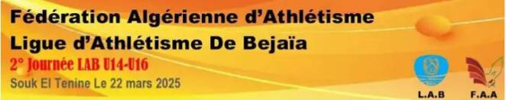

Statistiques 2° Journée LAB U14-U16 du 22 Mars 2025

|  |  |  |  |  |  |  |  |  |
| --- | --- | --- | --- | --- | --- | --- | --- | --- |
| **N°** | **Clubs** | **Filles** | | | **Garçons** | | | **Total gl** |
| **U14** | **U16** | **Total** | **U14** | **U16** | **Total** |
| **1** | MBB | 2 | 14 | **16** | 6 | 17 | **23** | **39** |
| **2** | RSB | 10 | 12 | **22** | 3 | 2 | **05** | **27** |
| **3** | EATas | 4 | 6 | **10** | 7 | 5 | **12** | **22** |
| **4** | CSSET | 5 | -. | **05** | 10 | 5 | **15** | **20** |
| **5** | EALOTA | 7 | 2 | **09** | 9 | 3 | **11** | **20** |
| **6** | AMCB | 1 | 5 | **06** | 5 | 6 | **11** | **17** |
| **7** | JSIA | 4 | 6 | **10** | 1 | 5 | **06** | **16** |
| **8** | ATA | 4 | 1 | **05** | 8 | 2 | **10** | **15** |
| **9** | EMSA | 8 | 3 | **11** | 3 | 1 | **04** | **15** |
| **10** | ESA | 12 | 1 | **13** | - | 2 | **02** | **15** |
| **11** | JSBM | 5 | 4 | **09** | 4 | 2 | **06** | **15** |
| **12** | ACSA | 3 | 7 | **10** | 1 | 2 | **03** | **13** |
| **13** | CREB | 6 | 2 | **8** | 5 | - | **05** | **13** |
| **14** | ECB | 5 | 1 | **06** | 4 | 3 | **07** | **13** |
| **15** | ACA | 3 | 8 | **11** | - | 2 | **02** | **13** |
| **16** | RBS | 2 | 2 | **04** | 3 | 4 | **07** | **11** |
| **17** | EVB | 4 | 4 | **08** | - | 1 | **01** | **09** |
| **18** | ASROUDHA | 2 | 1 | **03** | 4 | 2 | **06** | **09** |
| **19** | CSTD | - | - | - | 9 | - | **09** | **09** |
| **20** | THBA | 3 | - | **03** | 2 | 4 | **06** | **09** |
| **21** | CAMOA | 6 | - | **06** | - | - | **-** | **06** |
| **TOTAL** | | **106** | **79** | **185** | **84** | **68** | **152** | **328** |